Atitit 表格统计模块 表格数据体积 索引体积 行数分布 pgsql

select relname as tablename,n_live_tup as lines_rowcount, pg_size_pretty( pg_relation_size(relid)) as tablesize, pg_size_pretty( pg_table_size(relid)) as tablesize_noindexsize ,

pg_size_pretty( pg_total_relation_size (relid)) as total_relation_size , pg_size_pretty( pg_indexes_size (relid)) as indexes_size , *

from pg_stat_user_tables where relname like 'vaf%' order by tablename

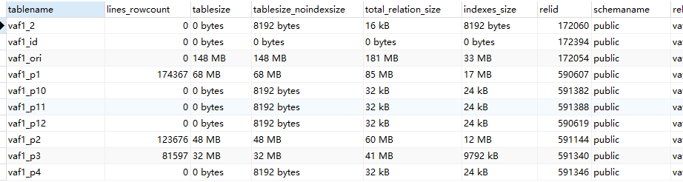

按照体积倒排 查找大表

select relname as tablename,n_live_tup as lines_rowcount, pg_size_pretty( pg_relation_size(relid)) as tablesize, pg_size_pretty( pg_table_size(relid)) as tablesize_noindexsize ,

pg_size_pretty( pg_indexes_size (relid)) as indexes_size , pg_size_pretty( pg_total_relation_size (relid)) as total_relation_size , pg_total_relation_size (relid) as total_relation_size_int , *

from pg_stat_user_tables where relname like '%%' order by total_relation_size_int desc